ENR 106 PROJECT   
REPORT ON FARMEASE

* GROUP MEMBERS:
  + JAY DAFTARI(AU2440271)
  + HET PATEL(AU2440266)
  + PRAKSHAL SHAH(AU2440265)

FarmEase: A Farmer's Aid System

**1. Introduction**

* **Overview**

**FarmEase is an intuitive software platform tailored to assist farmers in managing essential farming needs such as purchasing seeds, fertilizers, renting or buying vehicles, and accessing support services. It aims to simplify farmers' lives by centralizing resources and enhancing decision-making processes through a user-friendly interface.**

* **Objectives**

1. **Provide a unified platform for farmers to manage farm-related activities effortlessly.**
2. **Simplify access to agricultural inputs and services, saving time and effort.**
3. **Support informed decision-making by offering relevant, organized information.**

**2. End-Users of the Software**

**FarmEase serves multiple user roles, each with tailored functionalities:**

1. **Admin: Manages the overall system, oversees transactions, and generates reports.**
2. **Farmers (Customers): Use the platform for purchasing, renting, and accessing farming services.**
3. **Vendors/Dealers: List and manage products such as seeds, fertilizers, and vehicles for sale or rent.**
4. **Employees/Support Staff: Assist farmers, handle queries, and coordinate logistics.**

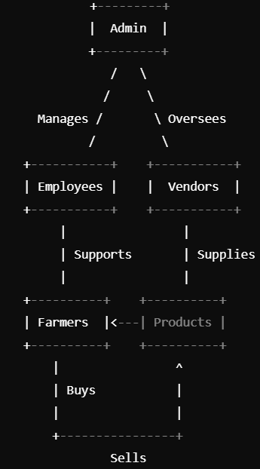

**3. Main Modules and Features**

**3.1 Admin Dashboard**

* **User Management: Add, edit, and delete accounts for farmers, vendors, and employees.**
* **Transaction Monitoring: Approve and monitor sales and rental transactions.**
* 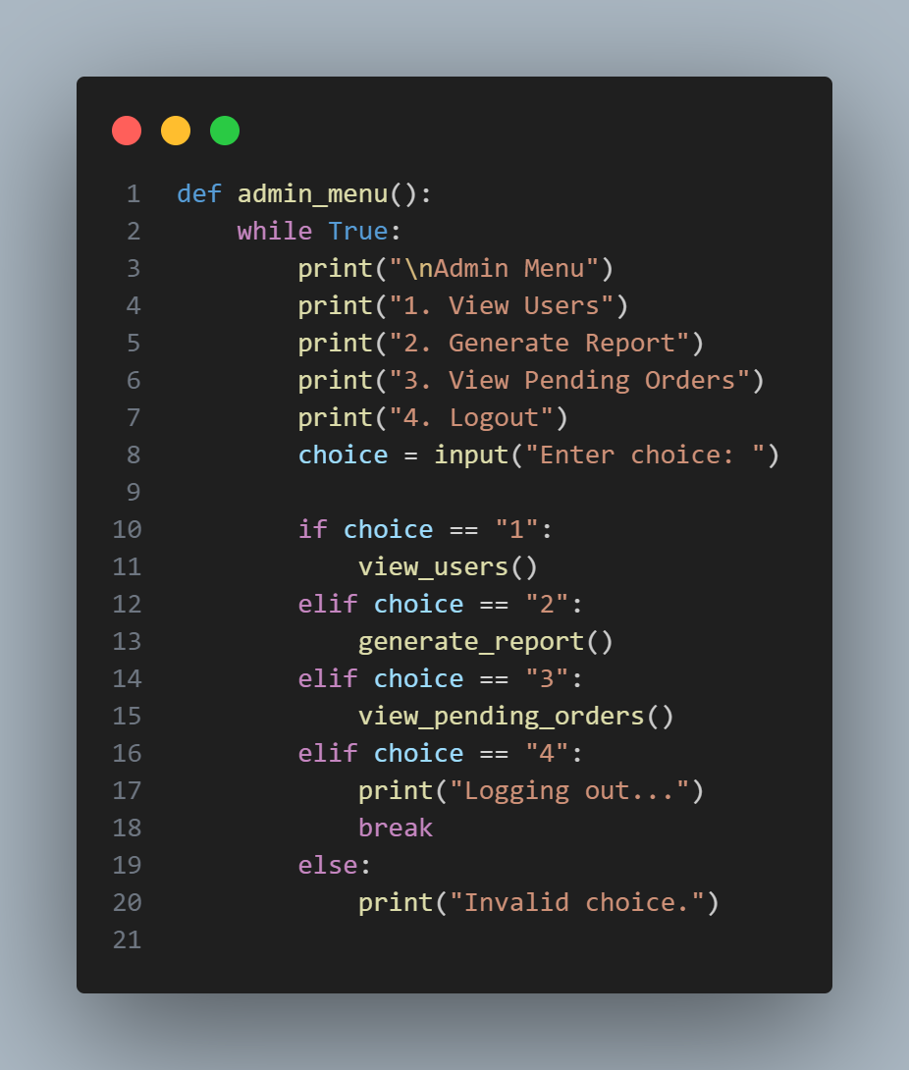**Report Generation: Generate detailed reports on sales, rentals, and user activity.**

**3.2 Farmer (Customer) Dashboard**

* **Seed Purchase: Browse and filter seeds by type, season, and price.**
* **Fertilizer Purchase: Explore fertilizers with descriptions, usage tips, and pricing.**
* **Vehicle Renting: Find tractors, trucks, and other equipment for rent.**
* **Vehicle Purchase: Compare vehicles for purchase based on budget and requirements.**
* **Order History: Review past transactions for better planning.**
* **Support: Submit inquiries or report issues directly to support staff.**

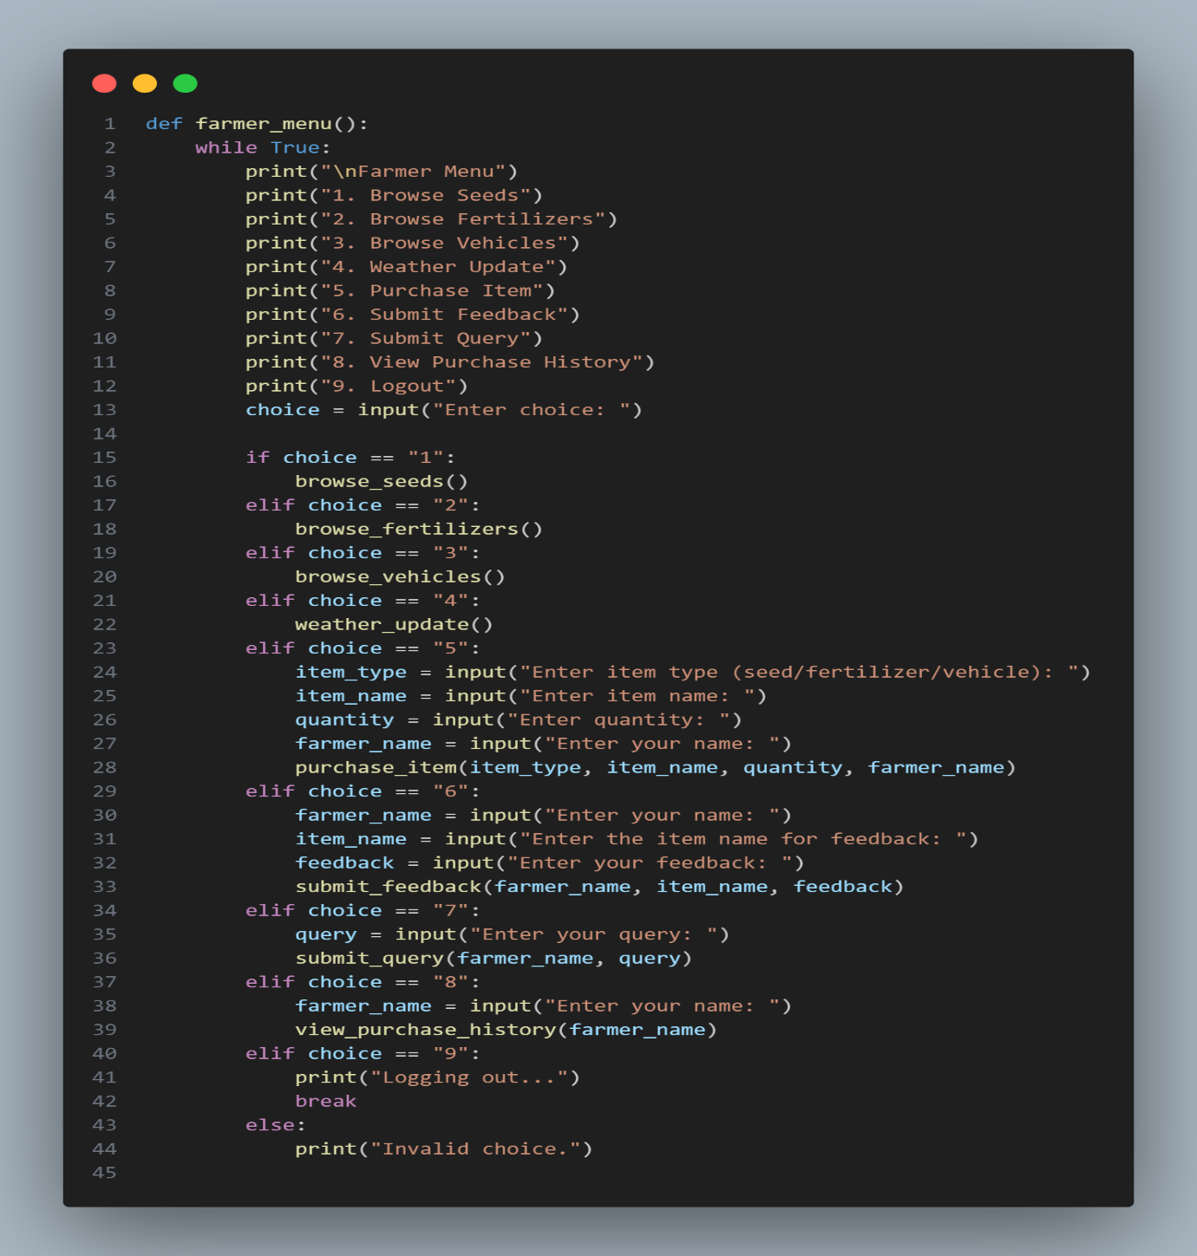

**3.3 Vendor/Dealer Portal**

* **Product Listing: Upload and manage listings for seeds, fertilizers, and vehicles.**
* **Order Management: View, process, and deliver orders efficiently.**
* 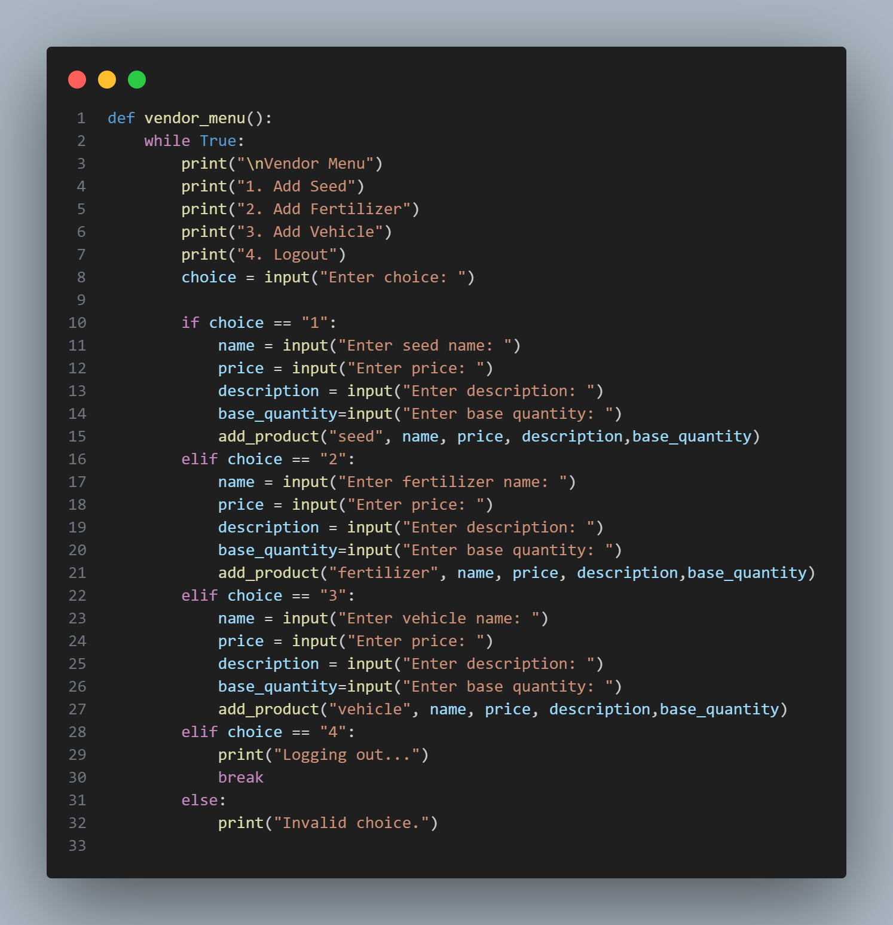**Revenue Reports: Access insights into sales and rentals to track performance.**

**3.4 Employee/Support Staff Module**

* **Query Management: Address farmer inquiries promptly through chat or calls.**
* **Logistics Coordination: Manage deliveries and rentals in collaboration with vendors.**

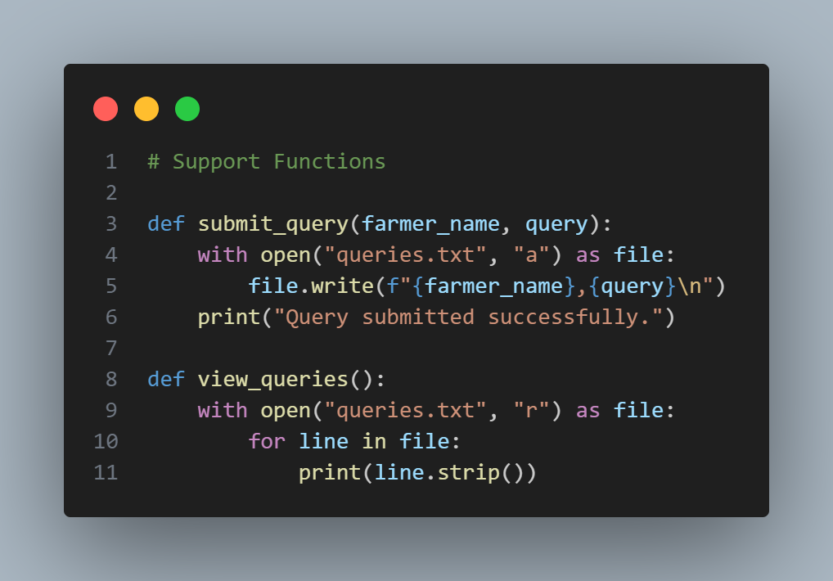

**4. Unique Aspects**

1. **Simplicity: Designed for rural farmers with limited technical expertise.**
2. **Language Support: Includes integration with local languages and voice-based navigation.**
3. **Future Scalability: Modular design allows for adding features like weather updates or crop advisories.**

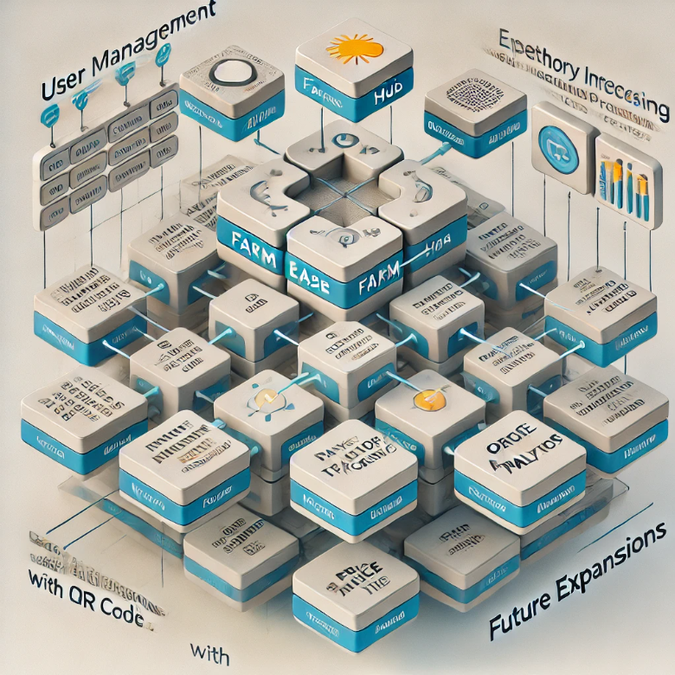

**5. System Workflow**

**5.1 Farmer Interaction**

1. **Farmer logs in and accesses the dashboard.**
2. **Browses through the required module (e.g., Seed Purchase).**
3. **Places an order, which is processed by vendors and coordinated by support staff.**

**5.2 Vendor Interaction**

1. **Vendors list products with pricing and availability.**
2. **Receive and process orders, updating stock as required.**

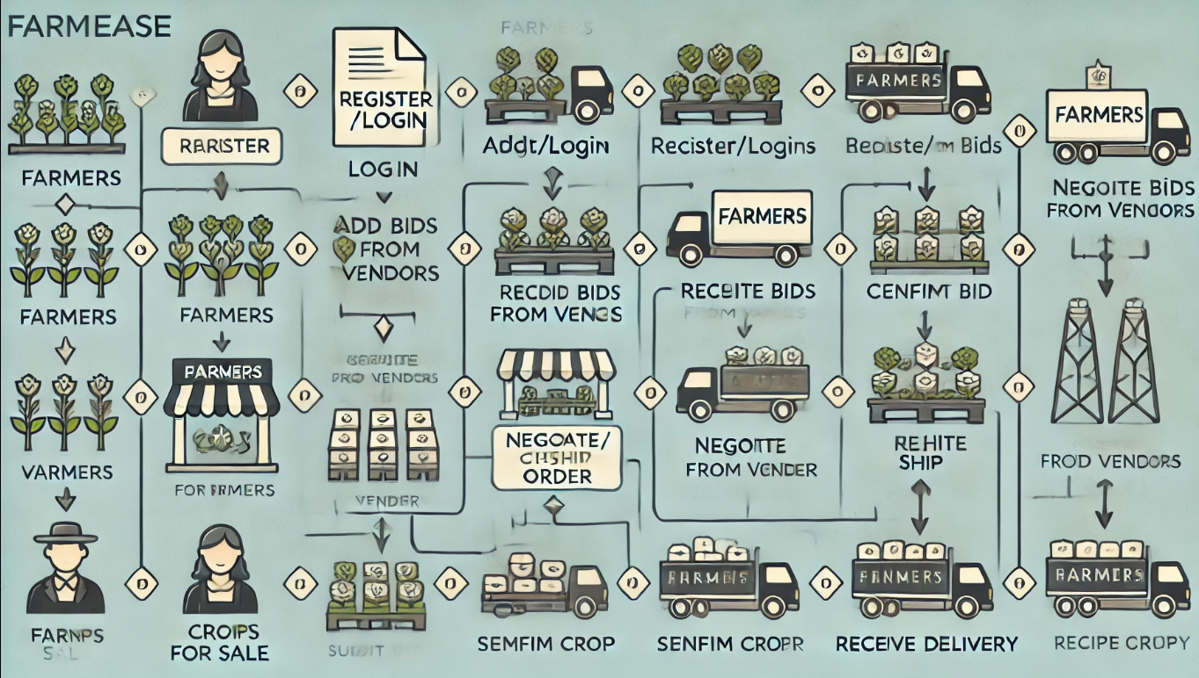

**6. Benefits of FarmEase**

1. **Time Efficiency: Farmers can access all required inputs in one place.**
2. **Enhanced Decision-Making: Detailed information helps farmers make informed choices.**
3. **Ease of Use: Localized features ensure inclusivity for non-tech-savvy users.**
4. **Improved Communication: Direct channels for support and logistics streamline processes.**

**7. Future Prospects**

**FarmEase envisions incorporating:**

1. **Weather Updates: Real-time weather forecasts for better planning.**
2. **Crop Advisory: Suggestions for crop types based on soil and climate data.**
3. **E-learning Modules: Educational content to enhance farming knowledge.**

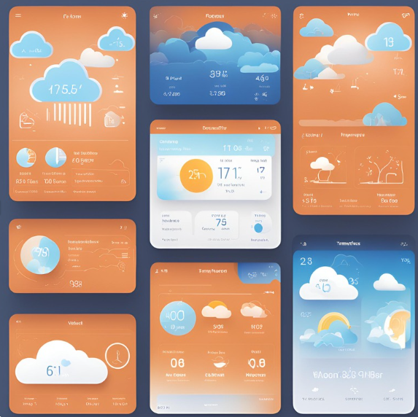

**8. Conclusion**

**FarmEase is a transformative initiative aimed at empowering farmers with technology. By centralizing resources, the platform not only simplifies farming activities but also strengthens the agricultural ecosystem, ensuring that farmers can thrive in a competitive and dynamic environment.**

